DIRECTIONS
Apedale Community Country Park
Loomer Road, Chesterton, Newcastle-under-Lyme, Staffordshire,
Tel: 07754 172801

Adopted in 2016 by Newcastle (Staffs) AC |  |  | Permit Number  2016-27172

Start: 11.00 am
“THE NEWCASTLE DALES DASH”
(Incorporating the Margaret Barker Trophies)

10K MULTI-TERRAIN RACE
on Sunday 4th December 2016 at Apedale Community Country Park

- Explore 200 hectares of woods, meadows and pools

Newcastle (Staffs) Athletic Club.

Organised by:

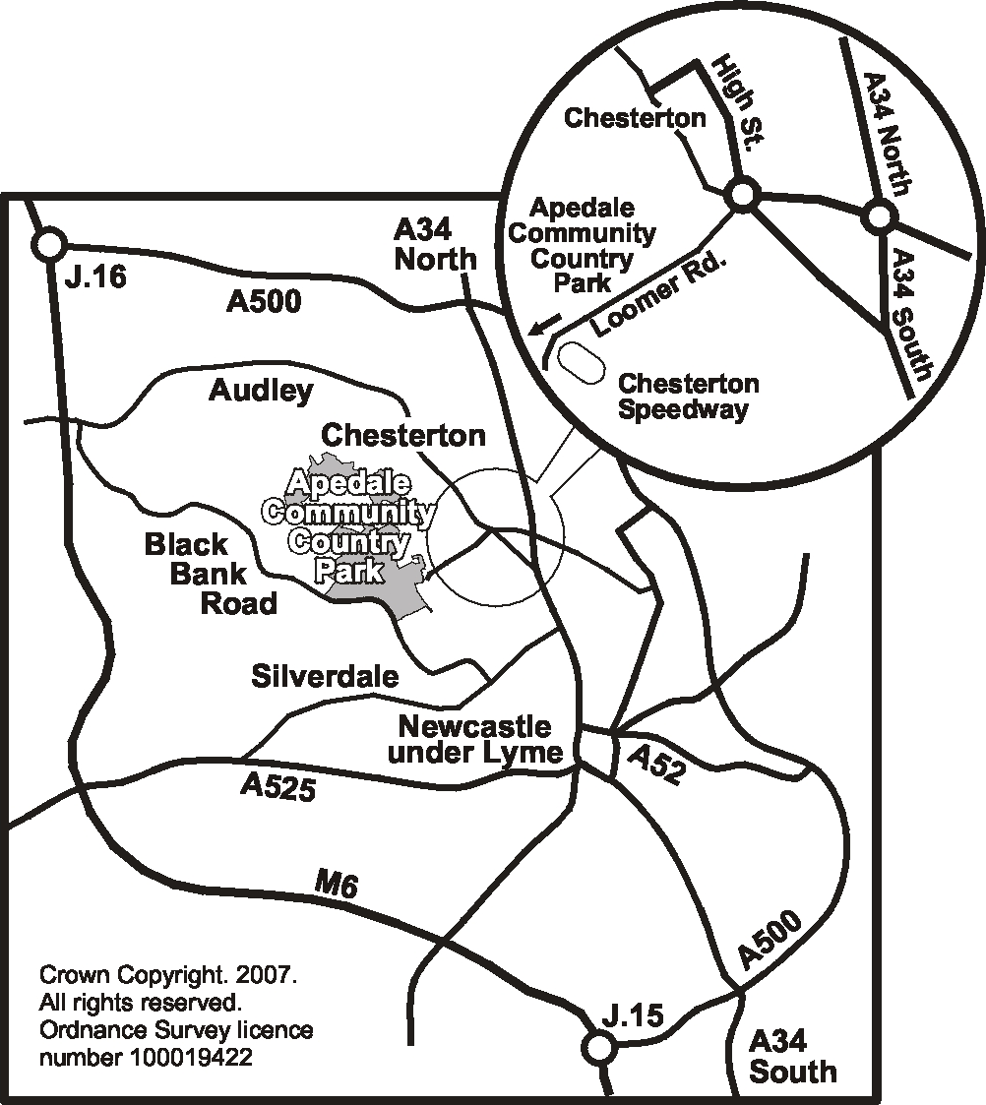
Crown Copyright. 2007. All rights reserved. Ordnance Survey licence number 100019422
- Guided walks and activities for schools and community groups by Newcastle Countryside Project
The Newcastle Dales Dash:
- Prizes for 1st 3 men and women, 1st male vet over 40/50/60/70, 1st female vet over 40/50/60/70 and Margaret Barker trophies for 1st lady and 1st Newcastle AC lady, also 1st U16 on the day, Male and Female, free results, e-mail address essential
- Commemorative Aynsley China mug for all runners
- Run under UK Athletics Rules
- Changing area & toilet facilities, but no showers,
- Café and Museum & car park
- Staffordshire County Council Ranger Service
- Café and toilet facilities at the Apedale Heritage Centre
- Underground tours of Apedale Drift Mine
- Special events throughout the year
ENTRY FORM
AYNSLEY CHINA

Sponsors:

ENTRY FORM
Please complete clearly in block capitals
Surname: |  |  |  |  |  |  | First Name:
Date of birth: |  |  |  |  |  |  | Sex: |  |  |  | Male/Female
Address:
 |  |  |  |  |  |  |  |  |  | Post Code:
Phone No.: |  |  |  |  |  | Email:
Athletic Club: |  |  |  |  |  |  |  | UK Athletics No.:
NSRRA No.:
EMERGENCY CONTACT
Name: |  |  |  |  |  |  | Phone No.:

ENTRY FEE: UK Athletics Affiliated Club £7.00 / Unaffiliated £9.00, entry on the day £2 extra. Cheques payable to Newcastle (Staffs) AC.

Entries Online to: www.runnersworld.co.uk or www.bookitzone.com or www.runbritain.com and printable form from Newcastle(Staffs) AC website.
Postal entries should be sent to: | Bill Barker  109 Nantwich Road  Audley,ST7 8DL
Closing date for postal entries is Wednesday, 30 November 2016.
To receive number in advance, please enclose a SAE, otherwise numbers should be collected from 9.00am on the day at Race HQ. Personal information is collected for the purposes of Race Administration only.
Entries on the day will also be taken from 9.00am onwards.
I declare that I am an amateur as defined by the UK Athletics Rules, will abide by the race rules and I will be 15 years of age, or over, on race day.
I hereby agree that the organizer shall not be liable for any accidents, injury, loss or damage as a consequence of my participation in the event.

Signed: _____________________________ Date:______________

Race photos by Bryan Dale available at:
www.racephotos.org.uk

“THE NEWCASTLE DALES DASH”
11.00am, Sunday 4th December 2016 .
at APEDALE COMMUNITY COUNTRY PARK
Apedale Valley, Loomer Road, Chesterton, Staffs. Tel: 07754172801

Now 12 years old, we are pleased to announce that Newcastle(Staffs) AC has adopted this event. Our thanks go out to AYNSLEY CHINA our Sponsor and
our hosts the Ranger Service at the Apedale Community Country Park.
The "Margaret Barker Trophies" will be presented as a tribute to Margaret from her friends at Newcastle Countryside Project and Newcastle (Staffs) Athletic Club. Four trophies will be awarded; one for the first lady home and one for the first Newcastle (Staffs) Athletic Club lady. A trophy will be presented to the 1st U16 on the day M/F The 10K course is measured and certified as accurate. It is an off-road, multi-terrain route that undulates through Apedale and Lymedale. The third Newcastle dale, Silverdale, can be seen on the right, at the top of the course, near Black Bank.
The surfaces include tarmac, limestone, grass and a wooden boardwalk. Certain areas are expected to be wet and muddy and care must be taken, especially if there is a frost. Appropriate footwear should be worn for the prevailing conditions on the day. The race is open to runners aged 15 and over but is, regrettably, unsuitable for wheelchairs or cyclists. Please note that St John Ambulance will be in attendance on the day at the Start/Finish Area and there will be drinks available at the finish. Parking is ample. The race start and finish area is the same as previous years. Entry limit 500.

